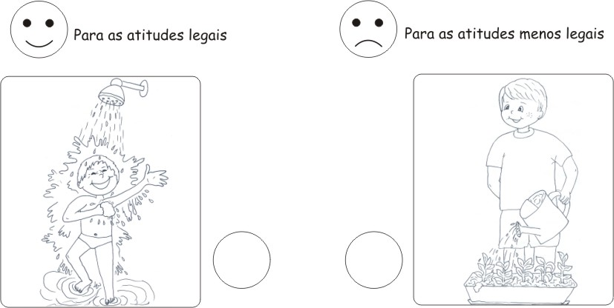
For not so nice attitudes
For good attitudes

