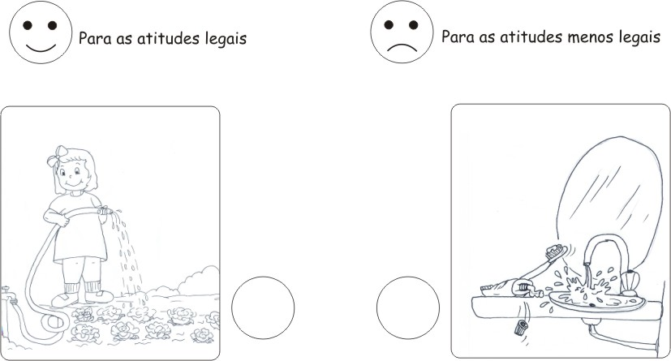
For good attitudes
For not so nice attitudes

