Please answer this questionnaire which is about Allan Kardec’s biography. You can find the answers at the word finder and then match them with the sentences displayed here below.

______________________ Denizard Rivail was Allan Kardec’s name.
Allan Kardec was born in _________on the _________________ 1804.
He got married to a fine arts teacher called ____________ Gabrielle Boudet.
Allan Kardec works as a _____________ __________________.
In 1854, Professor Rivail heard about the ______________________.
Allan Kardec organised the teachings which were received from the ______________.
_________________________________ was the first one of the five fundamental works of Spiritism. It was published by Allan Kardec in 1857.
________________________ was the nom de plume adopted by Hippolyte Léon Denizard Rivail under which he published his books on Spiritism.
He also organised _________________________, ___________________________, ______________________ and ______________________.
Allan Kardec also published ________________________________.
Allan Kardec is considered the _________________________ of ________________.

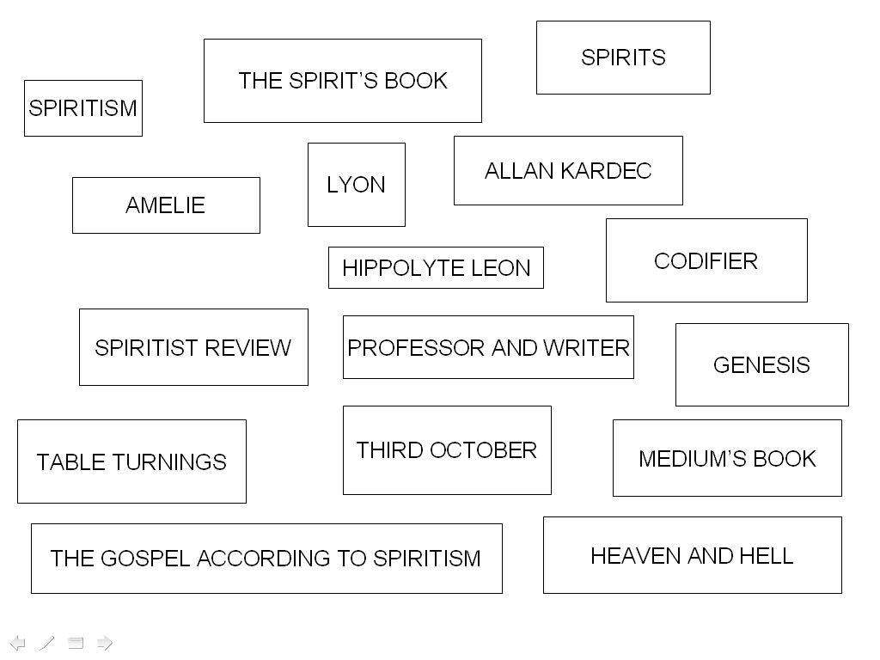

A | E | T | A | B | L | E | T | U | R | N | I | N | G | S | A | T | T | D
A | L | L | A | N | K | A | R | D | E | C | E | S | C | I | N | H | N | I
A | S | O | T | A | J | A | L | I | Y | S | S | I | N | T | L | E | O | T
F | C | L | R | S | E | A | R | R | T | T | E | E | S | S | A | G | D | H
L | O | Y | H | E | A | V | E | N | A | N | D | H | E | L | L | O | O | I
T | D | O | L | V | E | R | E | T | R | E | S | R | I | O | O | S | A | R
R | I | N | R | A | S | U | I | I | I | S | S | T | V | B | S | P | S | D
E | F | X | A | R | E | T | H | Y | T | I | U | C | B | V | V | E | V | O
Y | I | S | S | E | O | T | F | G | H | J | K | K | K | O | E | L | E | C
N | E | S | E | S | F | R | G | T | J | H | F | G | J | I | F | A | Z | T
O | R | O | M | R | V | T | S | S | S | T | Y | U | N | D | P | C | E | O
C | D | A | E | A | A | N | E | S | P | I | R | I | T | S | S | C | S | B
A | O | I | D | G | N | L | D | E | I | R | A | A | U | Z | N | O | E | E
H | R | N | I | B | C | Y | E | T | B | A | T | O | R | O | L | R | S | R
I | E | T | U | B | E | I | G | A | R | T | R | E | I | R | I | D | P | P
P | R | I | M | M | L | N | T | L | R | N | N | E | O | M | M | I | I | U
P | E | M | S | M | P | T | U | Q | B | R | R | X | B | R | O | N | R | I
O | S | S | B | S | O | I | R | G | A | R | O | P | R | R | C | G | I | A
L | P | E | O | I | E | U | I | R | N | O | U | I | S | P | R | T | T | N
Y | E | C | O | N | P | N | A | W | A | Q | A | Z | R | A | N | O | I | O
T | I | O | K | T | N | U | O | A | U | N | Y | I | A | S | V | S | S | A
E | T | N | D | R | N | O | S | D | A | R | A | U | E | E | I | P | M | I
L | O | L | I | V | P | O | D | O | S | A | S | P | I | R | I | I | O | S
E | O | L | U | V | R | E | D | D | S | E | V | P | H | R | I | R | B | S
O | A | R | N | A | E | O | V | I | S | O | T | S | U | P | S | I | E | T
N | S | S | S | R | O | I | I | B | Y | T | U | T | A | A | D | T | D | O
T | A | T | Y | R | E | U | S | E | N | T | I | F | O | P | A | I | S | A
S | S | P | I | R | I | T | I | S | T | R | E | V | I | E | W | S | A | I
T | H | E | S | P | I | R | I | T | S | B | O | O | K | I | T | M | S | L
A | P | R | O | F | E | S | S | O | R | A | N | D | W | R | I | T | E | R
O | S | A | R | T | Y | F | I | U | A | R | O | N | T | I | A | M | R | N
N | X | G | E | N | E | S | I | S | E | B | E | N | A | M | E | L | I | E

