PLEASE ANSWER THE FOLLOWING QUESTIONS IN RELATION TO THE PICTURES DISPLAYED

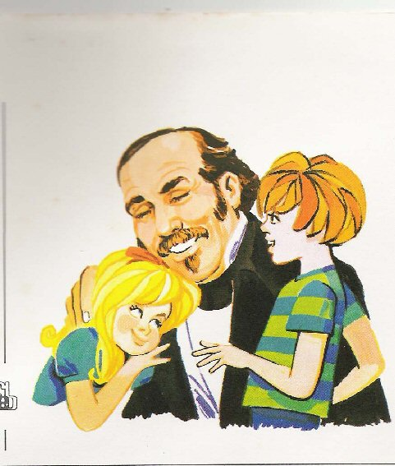Who is this guy?

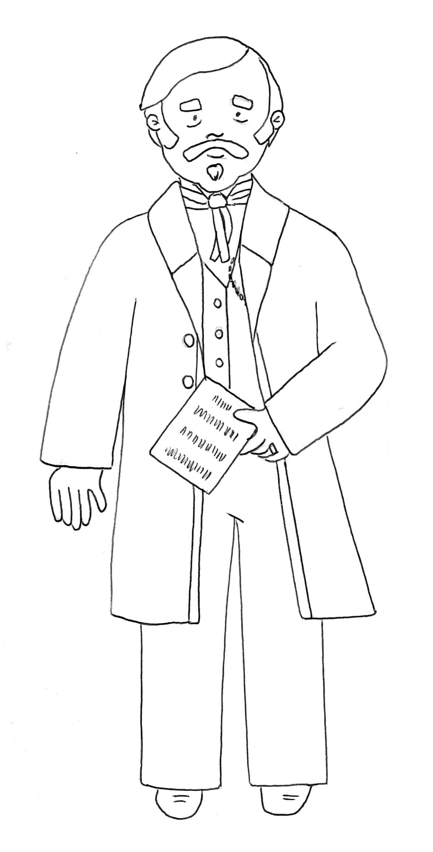 What has he done?

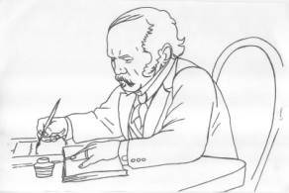 Which books has he published?

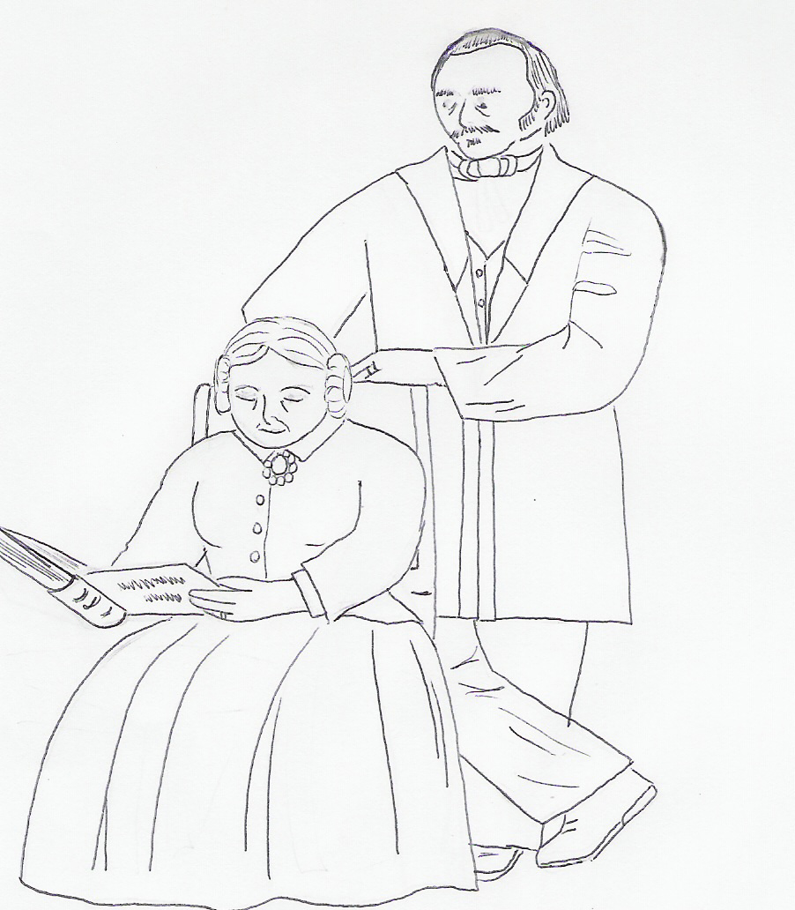 Who is this lady?

Activity sent us by Carolina von Scharten, London
Sir William Crookes Spiritist Society linked to
BUSS - The British Union of Spiritist Societies.

