Answer Sheet – Find the 10 Errors!

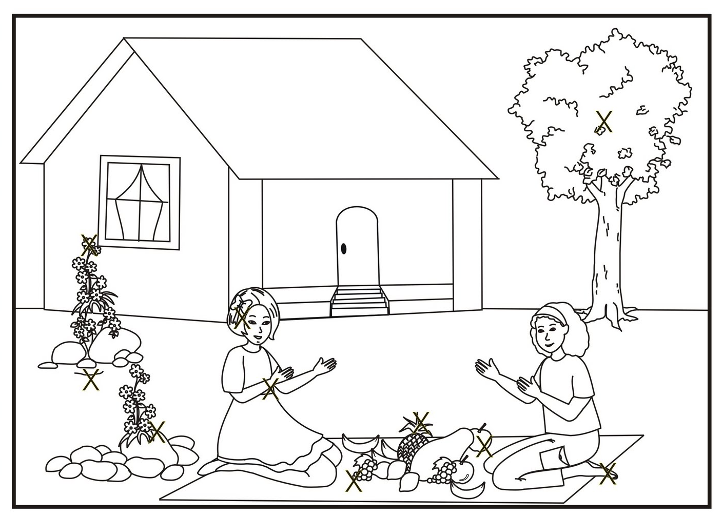

Source: Apostila da Aliança Municipal Espírita de Juiz de Fora (AME-JF)

Activity received from Carolina von Scharten, London
Sir William Crookes Spiritist Society linked to
BUSS - The British Union of Spiritist Societies.

