Animals are also blessed by God

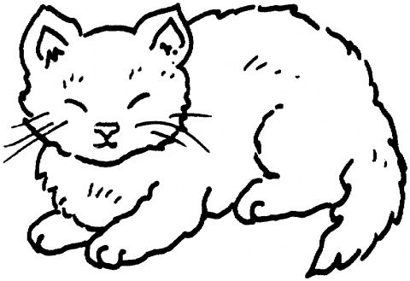

Source: Super Coloring

Activity received from Carolina von Scharten, London, Sir William Crookes Spiritist Society linked to BUSS - The British Union of Spiritist Societies.

