Colour the sea in blue and the Land in green

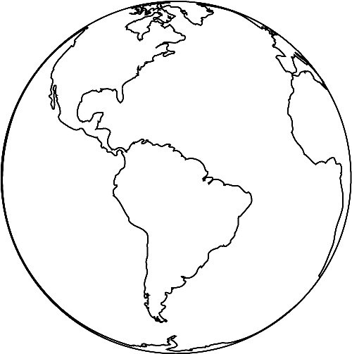

Source: Colorir Desenhos

Activity received from Carolina von Scharten, London, Sir William Crookes Spiritist Society linked to BUSS - The British Union of Spiritist Societies.

