Gluee cotton at the Rabbit Family’s fur!

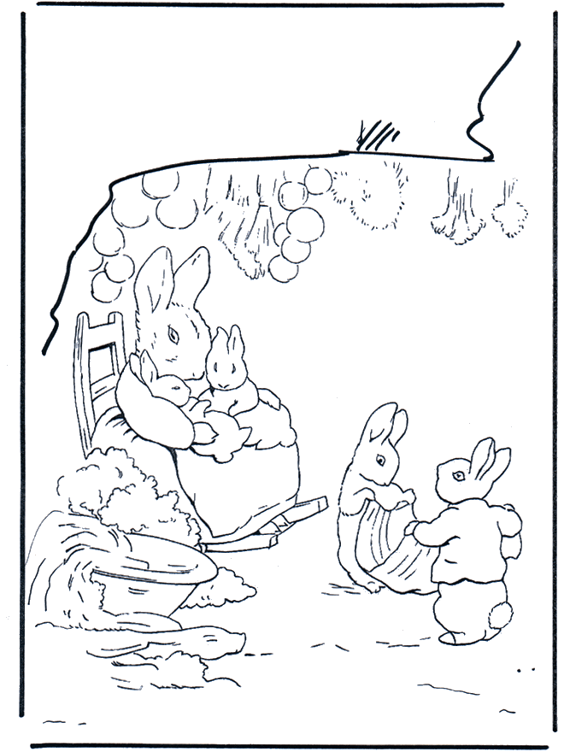

Source: desenhos.kids.sapo.pt

Activity received from Carolina von Scharten, London - Sir William Crookes Spiritist Society linked to
BUSS - The British Union of Spiritist Societies.

