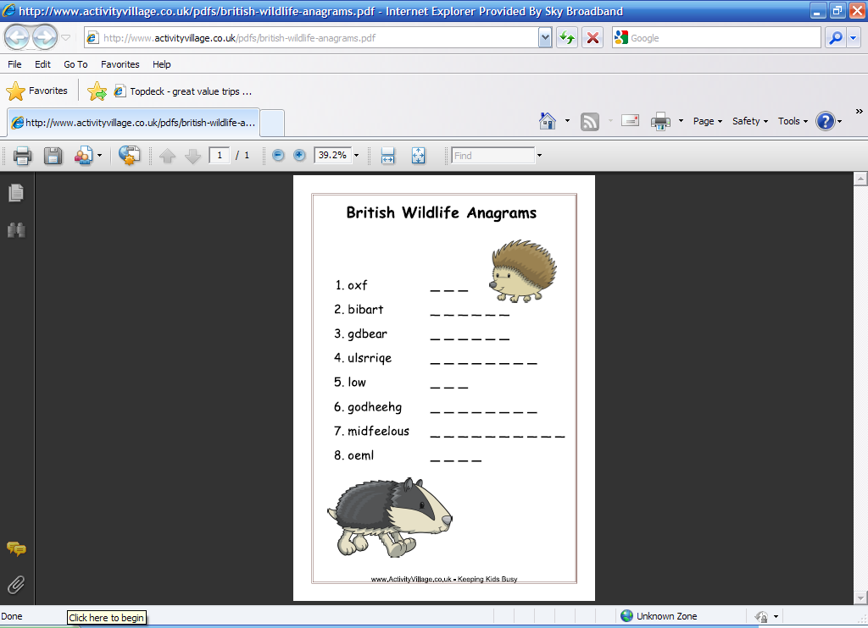Anagrama – Vida Animal

- AMCCAO __ __ __ __ __ __
- OELÃ __ __ __ __
- IGTRE __ __ __ __ __
- MATANDÁU __ __ __ __ __ __ __ __
- ABAOC __ __ __ __ __
- ACRBTOI __ __ __ __ __ __ __
- CVALAO __ __ __ __ __ __
- IGRAAF __ __ __ __ __ __
- GAPAIOPA __ __ __ __ __ __ __ __

Fonte: Activity Village

Atividade recebida de Carolina von Scharten, London
Sir William Crookes Spiritist Society linked to
BUSS - The British Union of Spiritist Societies.

