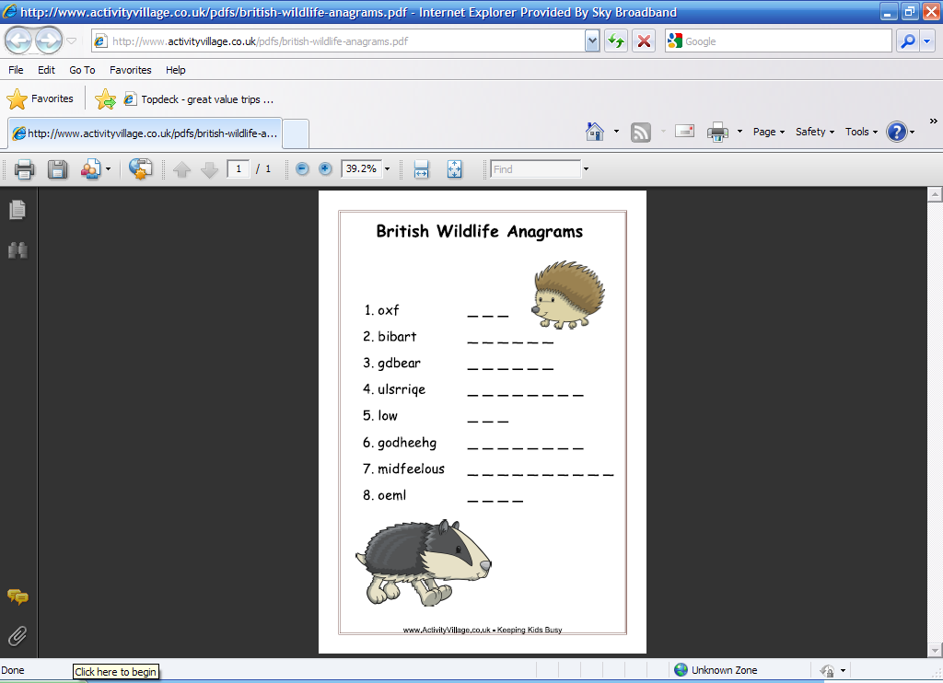Anagrama – Vida Animal

- MACACO __ __ __ __ __ __
- LEÃO __ __ __ __
- TIGRE __ __ __ __ __
- TAMANDUÁ __ __ __ __ __ __ __ __
- COBRA __ __ __ __ __
- CABRITO __ __ __ __ __ __ __
- CAVALO __ __ __ __ __ __
- GIRAFA __ __ __ __ __ __
- PAPAGAIO __ __ __ __ __ __ __ __

Fonte: Activity Village

Atividade recebida de Carolina von Scharten, London
Sir William Crookes Spiritist Society linked to
BUSS - The British Union of Spiritist Societies.

