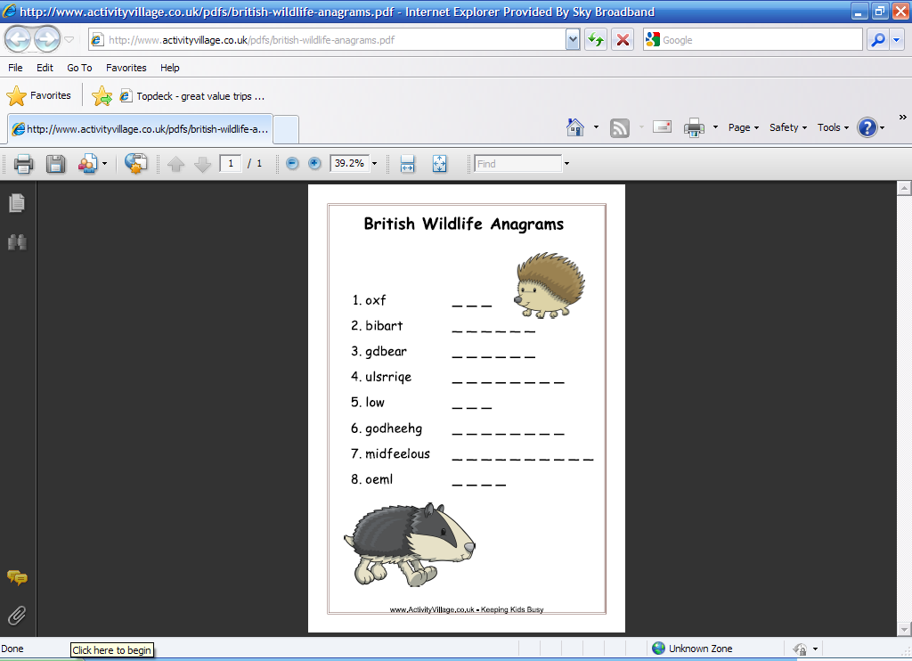Vida Animal – Caça Palavras

 | M | A | C | A | C | O | L | P
 | C | A | T | I | G | R | E | A
 | O | B | A | I | I | E | A | P
 | B | A | V | A | R | I | O | A
 | R | G | I | R | A | F | A | G
 | A | Y | Q | A | F | A | U | A
 | B | C | A | V | A | L | O | I
 | I | Q | W | C | G | L | I | O
 | T | A | M | A | N | D | U | A

- _____________________
- _____________________
- _____________________
- _____________________
- _____________________
- _____________________
- _____________________
- _____________________
- _____________________
Fonte: Activity Village

Atividade recebida de Carolina von Scharten, London
Sir William Crookes Spiritist Society linked to
BUSS - The British Union of Spiritist Societies.

