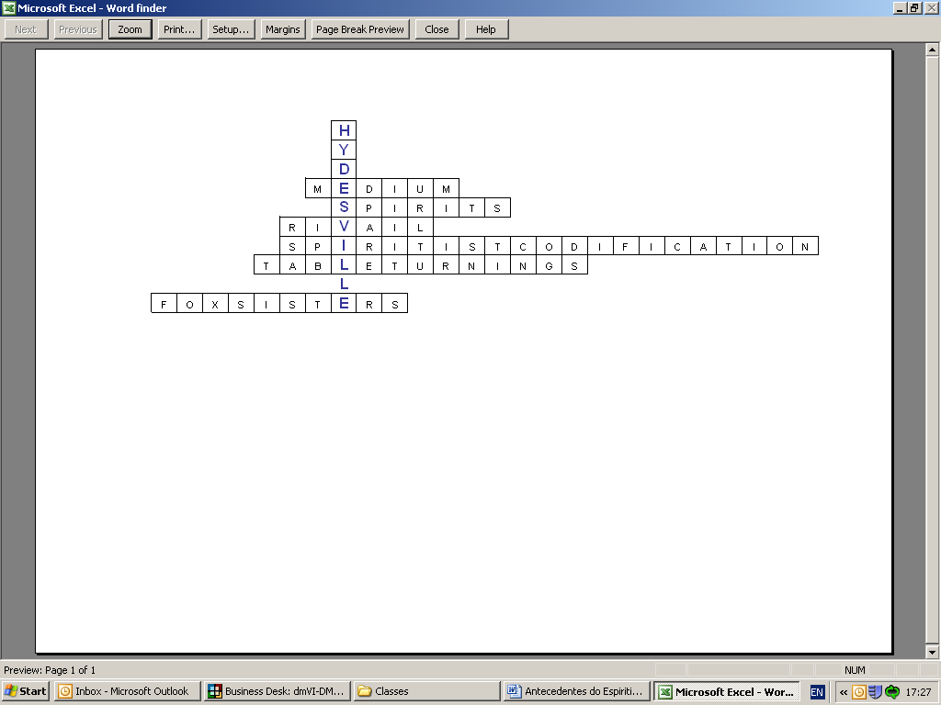
1 – Organization of information received from the spirits from the mediums.
2 – People who are "way"; "instrument" of communication between the incarnate and disincarnate.
3 - The table was a means of communicating with the spirits; the table would rotate with considerable rapidity, and would occasionally rise in the air, or perform other movements.
4 – French Professor who codified Spiritism.
5 – Girls who were mediums from the city of Hydesville.
6 – We are ___ and have a physical body.
RIVAIL SPIRITIST COFICATION
FOX SISTERS MEDIUM
SPIRIT TABLE TURNINGS
[Print]

