Do not follow a pathway, just because someone told you to do so. Follow the best option possible so you don’t regret later. Child, little child, don’t do something without reflecting/knowing what you are being asked to do. Listen to good friends, your parents and the teacher so you will always make the best choice.
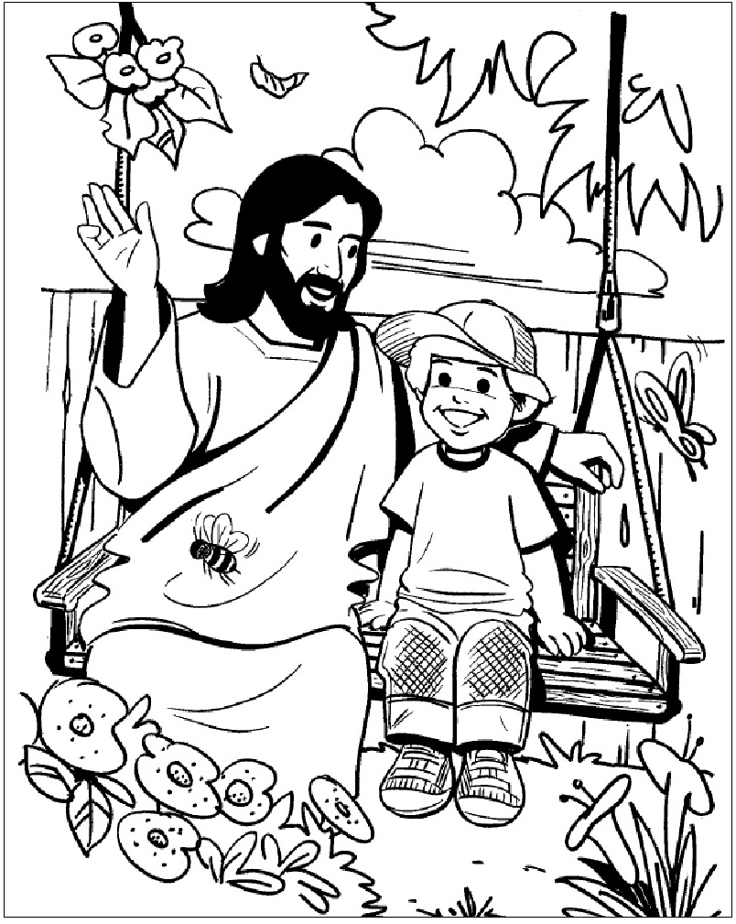
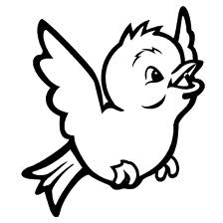
RESPECT THE ANIMALS AND THE NATURE. BE HAPPY!

