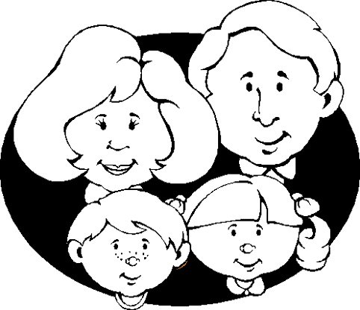
FAMILY

Represent your family in the space below. If you wish, you can also add others who are part of your "family" due to spiritual ties you have with them. Be creative and do what you like; using any technique. (Drawing, collage, origami, painting, etc.)..

Name: ______________________________________________________ _____/____/_____

