I AM SORRY

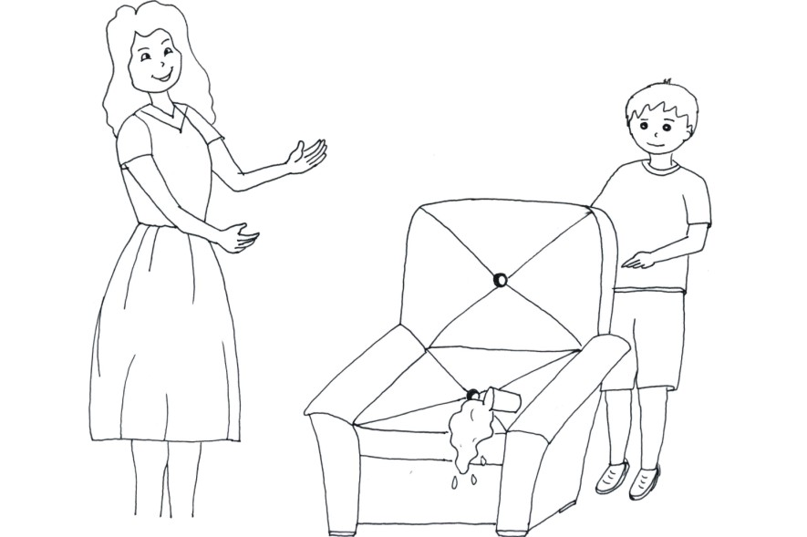

Diego was sitting on the couch watching TV at his home. He was drinking orange juice but just dropped it on the couch. His mother Angela walked in; she then asks:
- Who dropped juice in the couch?
Diego recalled his spiritist education classes, where he learned about the importance of telling the truth; of being honest. He also learned about magic words previously with his spiritist teacher too. He then replied to his mom:
- I was the one who dropped juice into the couch, mom. I am sorry; I didn’t mean to do it. I will clean it just now.
Angela could tell her son was saying the truth and didn’t mean to do it. She then said:
- My son I am the one who have to apologise to you, but please be more careful next time. Now let’s clean the juice before it dries.

PLEASE

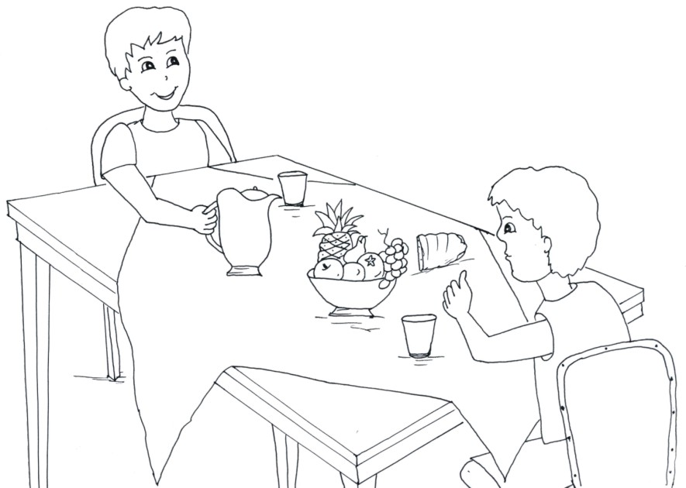

Jader was at the house of his friend Richard. They were drinking juice and eating sandwiches. The juice was really delicious; Jader wanted to drink more. He then asked his friend:
- Richard, can you please pass me the juice?
His friend Richard immediately gave him the jar. Jader knows that when asks for something and gets what he asked for he should be thankful. He then said:
- Thank you very much!

THANK YOU

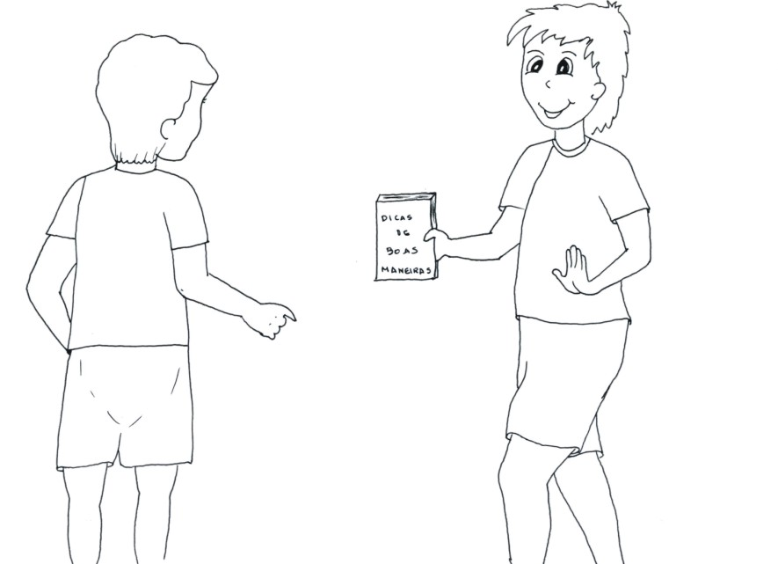

- Peter and John are classmates. They usually do their homework together and enjoy reading a lot. Hence, every time one of them gets a new book, they will read it and lend it to one another afterwards.
The last book Peter got as a present from his auntie is about Good manners. He read it and soon later lent it to John.
John knew how to take well care of things that didn’t belong to him: he didn’t damage his friends’ books. He read the book and soon later handed it back to Peter saying:
- Thank you! I really enjoyed this book.

EXCUSE ME

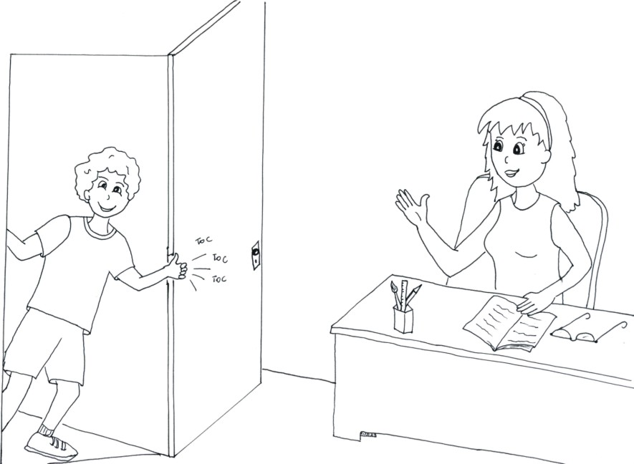

Lucas wanted to talk to his teacher about his football team. He wanted to train together with the older boys, but he would need her authorization to do that. Her room was located at the end of the corridor. Lucas walked towards it; when he got near he realised the door was closed.
He then knocked at it, opened slightly and said:
- Excuse me! Can I please come in to talk to you, Ma’am?
Her teacher welcomed him full of joy, since it’s always really good to talk to educated people.

