Self-knowledge Test – Saint Augustine
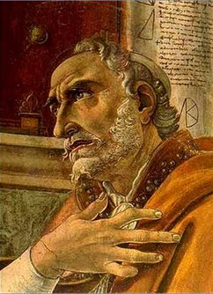

Every day Saint Augustine reflected on the attitudes he took, in order to improve and make it better on the following day. Please answer the questions below with honesty. This will help you reflect on situations where you could have reacted in a different way

Please describe good thoughts:__________________________________________
Please describe good actions: ___________________________________________
Please describe good words: ____________________________________________

Please describe bad thoughts: __________________________________________
Please describe bad actions: ____________________________________________
Please describe bad words: _____________________________________________

Did I do something I would criticise on others?
__________________________________________________________________

__________________________________________________________________

Did I do something I would feel ashamed or embarrassed to tell anyone?
__________________________________________________________________

__________________________________________________________________

Does anyone have anything to say against me?
__________________________________________________________________

__________________________________________________________________

Have I done all the good that was within my power to do?
__________________________________________________________________

__________________________________________________________________

Spiritist teacher: Carolina von Scharten, London, Sir William Crookes Spiritist Society linked to BUSS - The British Union of Spiritist Societies.

