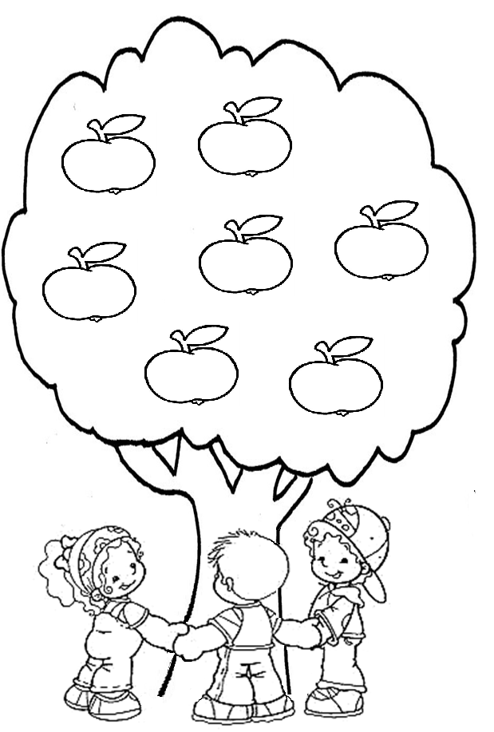
COLOUR THE APPLES THAT DEMONSTRATE CHARITY WITH YOUR NEIGHBOUR
TO LIE
TO HELP OTHERS
TO PRAY
TO FIGHT WITH FRIENDS
TO HELP WITH HOUSE DUTIES
RESPECT YOUR COLLEAGUES
TO USE THE MAGIC WORDS

