Connect the dots, find out the name of one of the basic books from the Spiritist Codification and write it within the book!

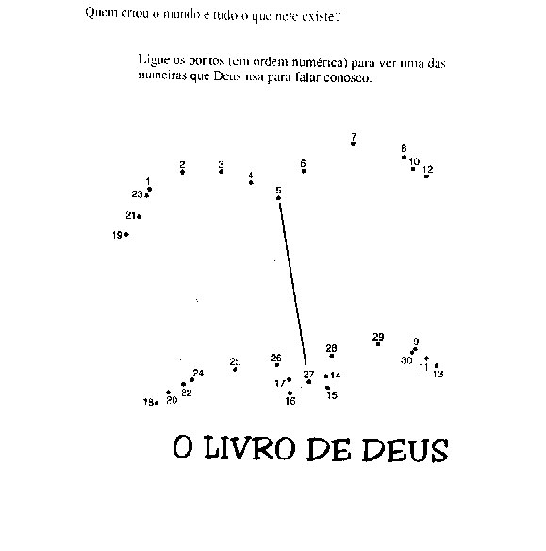

A B C D E F G H I J K L M N
1 2 3 4 5 6 7 8 9 10 11 12 13 14

O P Q R S T U V W X Y Z
15 16 17 18 19 20 21 22 23 24 25 26

________ ______________________ ____________________
20 8 5 7 15 18 16 5 12 1 3 3 15 18 4 9 14 7

______ ________________________
20 15 19 16 9 18 9 20 9 19 13

Activity sent us by Carolina von Scharten, London
Sir William Crookes Spiritist Society linked to
BUSS - The British Union of Spiritist Societies.

