Homework: Collaboration in the family
Let’s draw how we can also help at home!

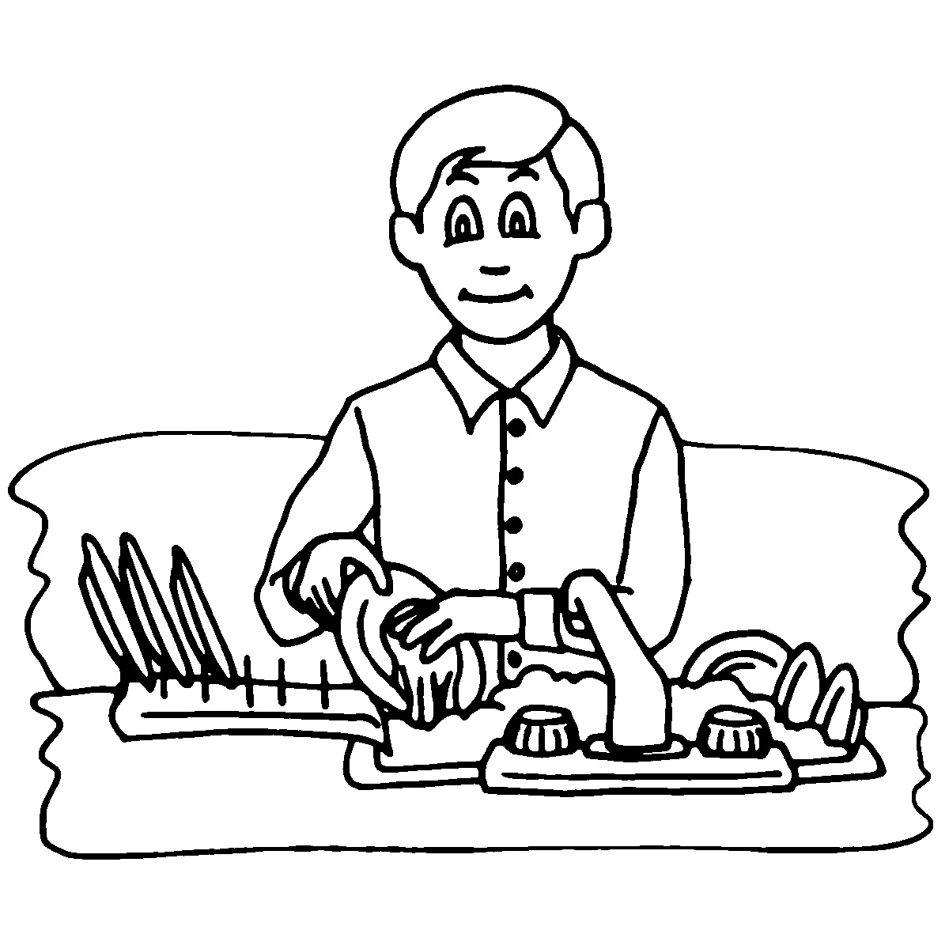
I help my mum _________________________________________________________________.

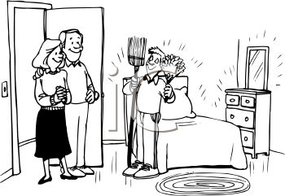

I always_________________________________________________________.

I learn that I can always help at home my family!

