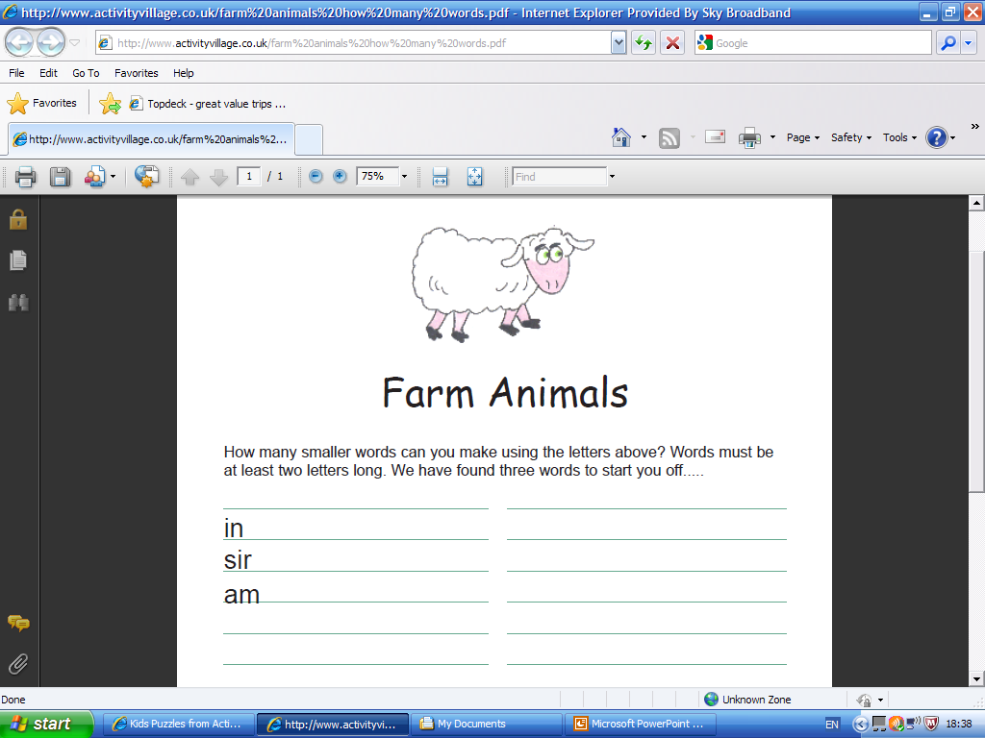

Animais da Fazenda

Quantas palavras você consegue escrever com essas letras?

ca_________________________________ ___________________________________

ma________________________________ ___________________________________

g___________________________________ ___________________________________

___________________________________ ___________________________________

___________________________________ ___________________________________

___________________________________ ___________________________________

Fonte: Activity Village

Recebido de Carolina von Scharten, London
Sir William Crookes Spiritist Society linked to
BUSS - The British Union of Spiritist Societies.

