Protector
Spirits

Responsability: Grupo Espírita Seara do Mestre
www.searadomestre.com.br/evangelizacao



- Daddy!
Carl, a seven year old boy, was being brought to the spiritist education classes at the spiritist centre by his mother.
- Dad, are you sure guardian angels don’t have any wings? Is that true?
Luis, Carl’s father, had a lot of experience as a spiritist teacher. He remembered some of the questions the children used to bring to his classes.


- No, my son. Little angels with wings and halos do not exist.
- But dad, who do I need to pray for, then?
- We can pray directly to God, to our Master Jesus or to our protector spirit.
- ? ? ?
- In the Spiritist Doctrine we prefer to call them protector spirits instead of angels. They are spirits like us, but they have already discarnate.
- Oh right, dad! Disincarnate is someone who died already, is that right?
- Yes, that’s right. These are spirits who have progressed morally due to the good actions practiced. They are now in the spiritual plane able to help us, inspiring us good thoughts. Therefore, they don’t decide on our behalf. It is our responsibility to be good, look after the nature, respect the others and love one another.
Carl paid close attention to his dad’s words. His dad then asked:
- What do you usually do when you are scared?
- I am not afraid of anything! – Carl said, lookign quite seriously at his father.
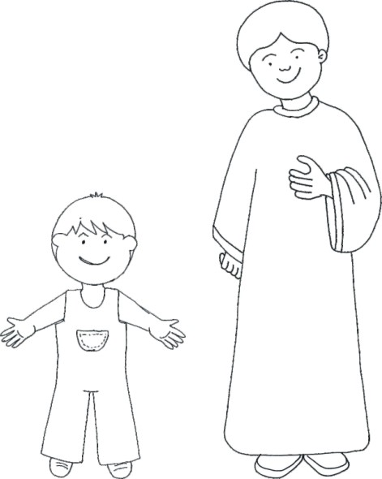
Luis, Carl’s dad, then recalled the boy was scared of thunderstorms and sleeping in the dark. Carl would always sleep with a nightlight on. He also remembered one night his child woke them up in the middle of the night because he was scared his parents, his brother and even his dog would die. Luis decided to just say:
- But what happens when tou feel afraid of something? You can do something which will help you a lot. Do you know what it is?
- I can pray?
- Yes, that’s right. You can pray. When we pray, our protector spirit connects to us and inspires courage and trust in God. Did you know that one day we will all be one protector spirit? It will depend on our moral progress; our evolution. It will depend on all the good things we do in our lifes.
- Oh, wow dad! This is so cool! It must be really cool to be a protector spirit and be able to help others.
Carl now decided to get his ball and invite his dad and dog to play with him. He was so excited and happy for learning a new lesson today.
Story: Amália Paz and Claudia Schmidt
Drawings: Cristina Chaves, Sociedade Espírita Casa do Caminho, bairro jardim das Palmeiras, Porto Alegre/RS

FOR OUR REFLEXION:

Jesus wants to look after all of us. He wants us all to feel protected. Since He is such a great friend, He gave us the opportunity to have one invisible friend each, who will help, protect and encourage us at all times.
This friend is a spirit who is always at our side; everyday. We call him protector spirit or guardian angel. We can get closer to him by praying and practicing good.

Translation: Carolina von Scharten, London, Sir William Crookes Spiritist Society linked to BUSS - The British Union of Spiritist Societies.

