Identify some of the topics discussed at the SPIRITIST EDUCATION CLASSES through the drawings below.

  ------------------------------- 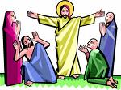---------------------------
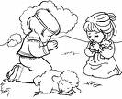-----------------------------------------------------------------

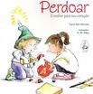--------------------------------------------------------

------------------------------------ 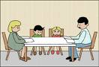--------------------------------------

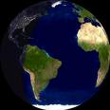-------------------------------- 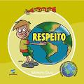----------------------------------------
DO YOU KNOW THESE PEOPLE?

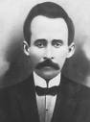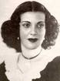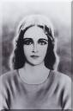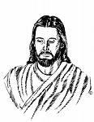

___________ ____________ ____________ ___________ __________

Activity sent by Nilda – Fraternidade Espírita Casa do Caminho / Belo Horizonte – MG.
Translation: Carolina von Scharten, London, Sir William Crookes Spiritist Society linked to BUSS - The British Union of Spiritist Societies.

