We learn, at spiritist education classes, about attitudes which help our spiritual evolution:
Find the way that leads to Spiritual Evolution:
Spiritist Education Classes
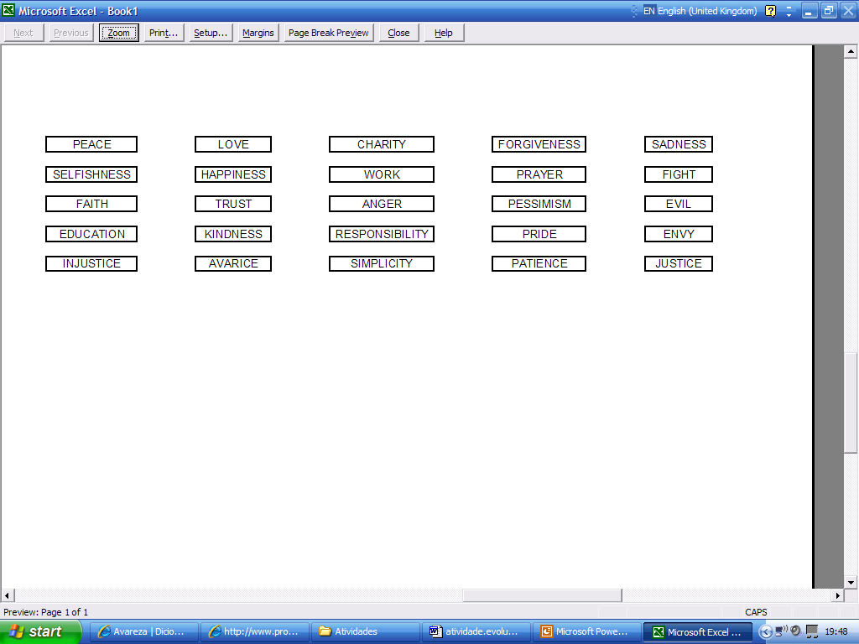
Spiritual
Evolution

Activity received from Carolina von Scharten, London - Sir William Crookes Spiritist Society linked to
BUSS - The British Union of Spiritist Societies.

