My Spiritual Body

c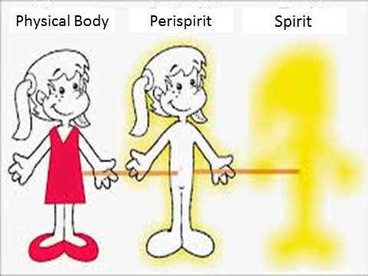

Now it’s your turn! Draw your physical body, perispirit and Spirit. Enjoy!

