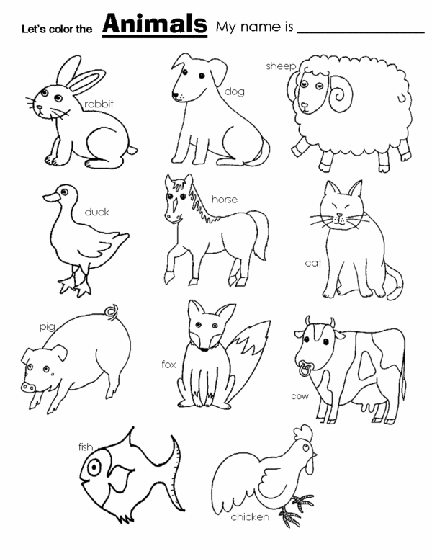

Source: Maggi Lli for kiddyhouse

Activity received from Carolina von Scharten, London
Sir William Crookes Spiritist Society linked to
BUSS - The British Union of Spiritist Societies.

