Complete the balloons with virtues we develop within the family:

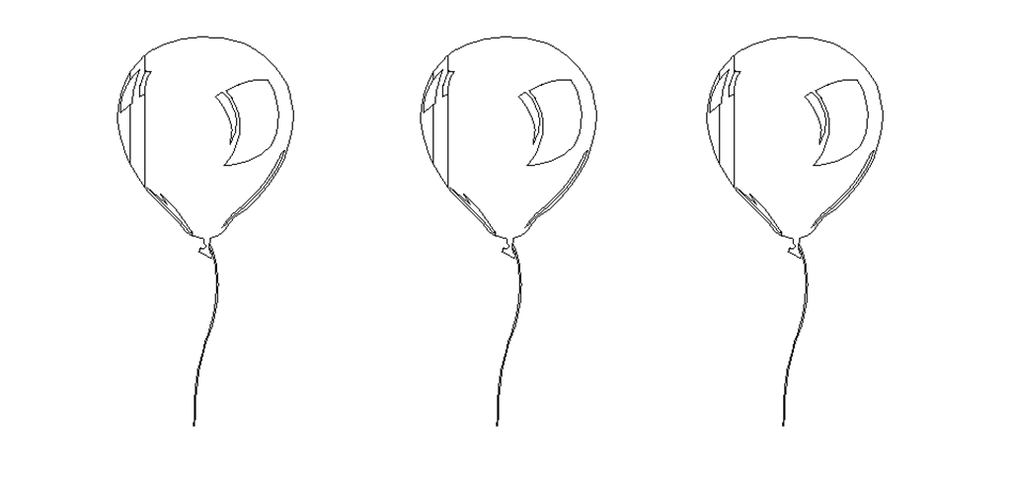

Activity sent us by Carolina von Scharten, London Sir William Crookes Spiritist Society linked to
BUSS - The British Union of Spiritist Societies.

