CRYPTOGRAM – Universal Family

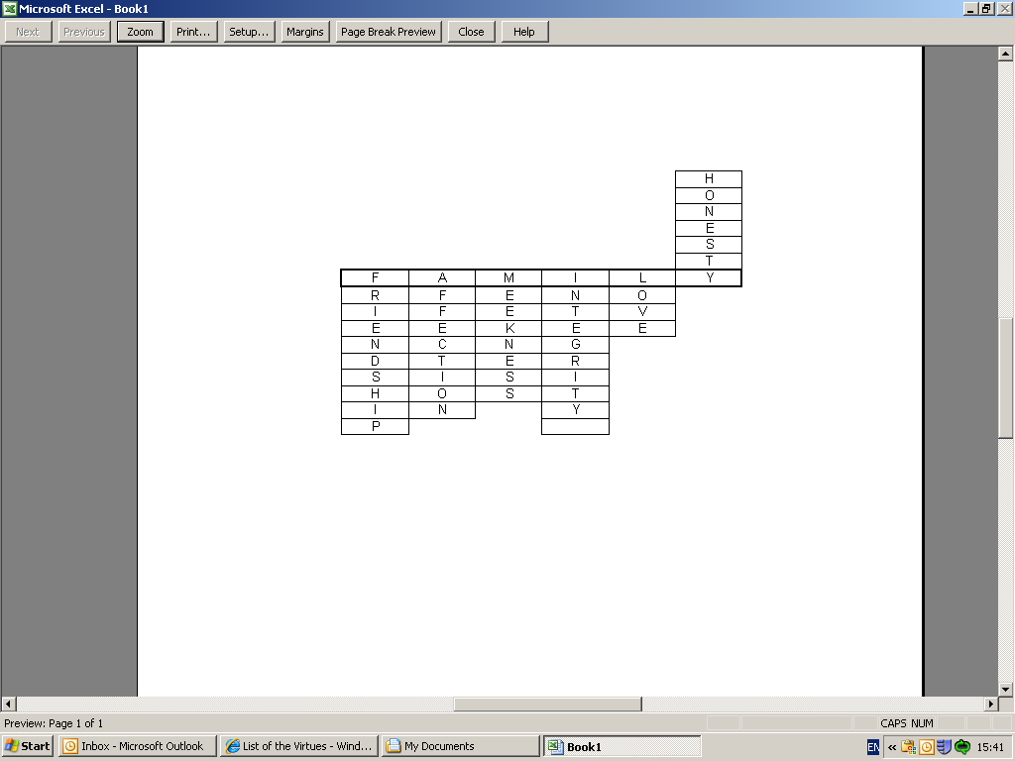

A B C D E F G H I J K L M N
1 2 3 4 5 6 7 8 9 10 11 12 13 14

O P Q R S T U V W X Y Z
15 16 17 18 19 20 21 22 23 24 25 26

1. _______________________ FRIENDSHIP
6 18 9 5 14 4 19 8 9 16

2. ____________________ AFFECTION
1 6 6 5 3 20 9 19 14

3. ____________________ MEEKNESS
13 5 5 11 14 5 19 19

4. ________________________ INTEGRITY
9 14 20 5 7 18 9 20 25

5. ____________ LOVE
12 15 22 5

6. ___________________ HONESTY
8 15 14 5 19 20 25

Activity sent us by Carolina von Scharten, London Sir William Crookes Spiritist Society linked to
BUSS - The British Union of Spiritist Societies.

