Name: __________________________________________________________

Colour these situations that are showing collaboration in the family:

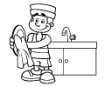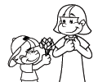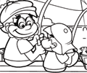

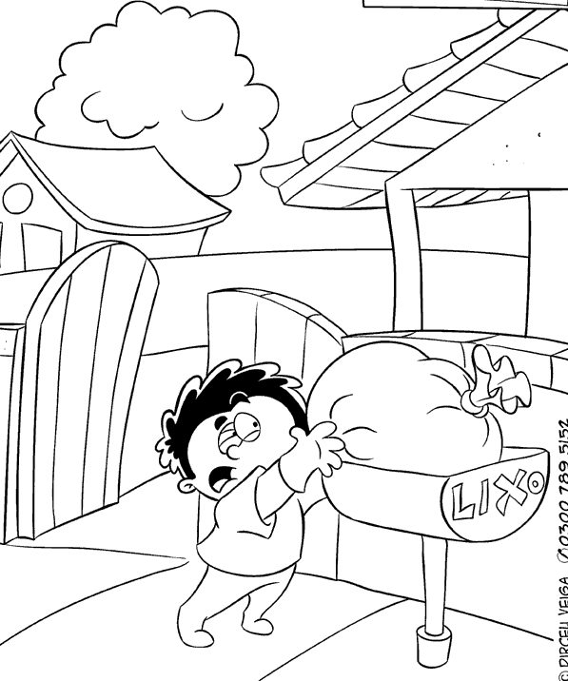

Images from the sites: Superkid and Dirceu Veiga

Activity received from Carolina von Scharten, London
Sir William Crookes Spiritist Society linked to
BUSS - The British Union of Spiritist Societies.

