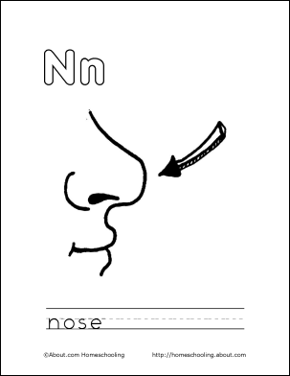

Fonte: About.com Homeschooling

