Homework: SHARING IS GOOD

What was the lesson you learned from the rainbow fish?
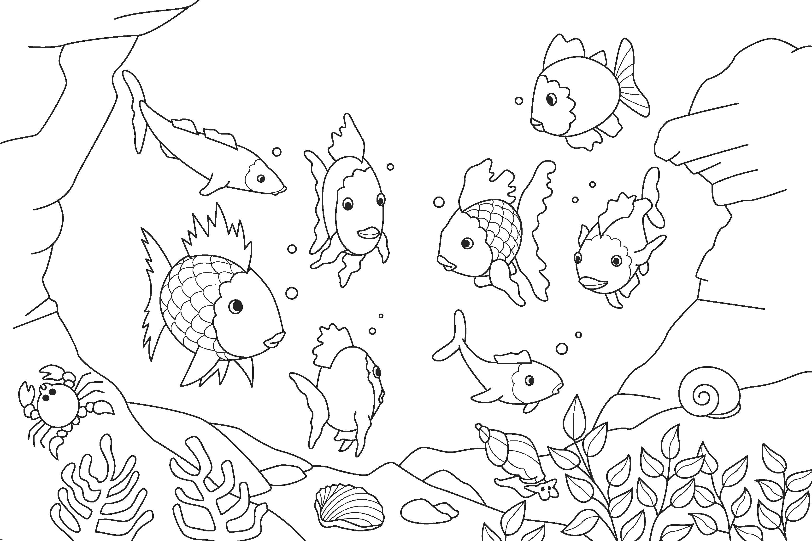

What did you learn from the brother and sister bear?

______________________________________

