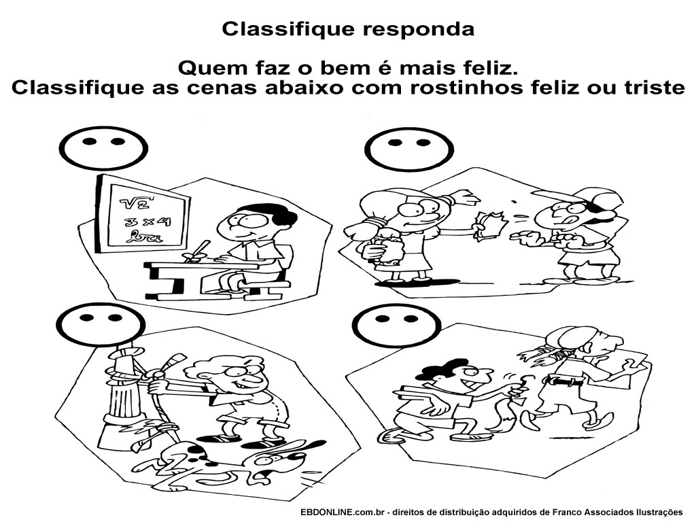
The happiest of people are those who practice goodness.
Do you think these attitudes are good or bad?
Please make a happy or sad face depending on the action related to each picture.

