Connect the numbers and find out who the disciples saw walking on water.
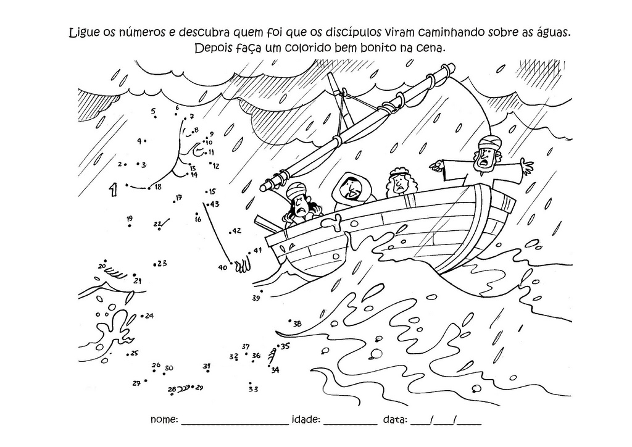
Source: Sementinha Kids

Activity sent us by Carolina von Scharten, London
Sir William Crookes Spiritist Society linked to
BUSS - The British Union of Spiritist Societies.

