Circle the SPIRITUAL TREASURES only from the list below:

Forgiveness Season Clothes Mobile Phone Patience Toys

Harmony Videogame Trust Study CD’s Kindness DVD’s
Gratitude New Trainers Joy Money Peace

Material things I-pod Good humour Bicycle Lap-top

Sensibility Car Education Beach holiday home

Watch Electronic Equipment Tenderness Faith

Write down the meaning of these expressions with your own words:

Material belongings:

Spiritual belongings:

He, our model and guide sent to us by God, is waiting for us and hoping we make efforts to progress spiritually and morally. How is He called? ………………….
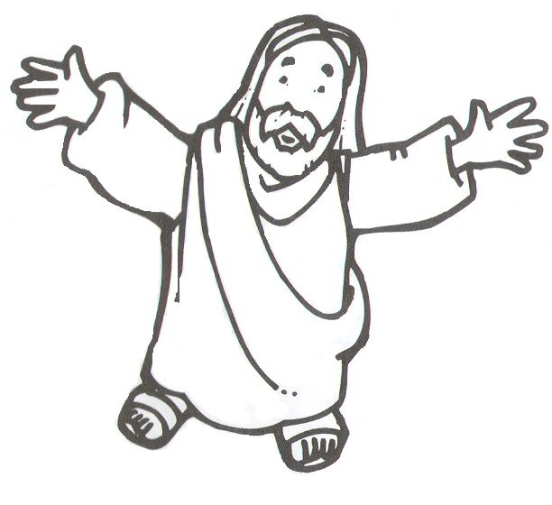
Picture from the site: Vera Stefanello

Activity sent us by Carolina von Scharten, London
Sir William Crookes Spiritist Society linked to
BUSS - The British Union of Spiritist Societies.

