Jesus always said this virtue was the one that cured!
Link Jesus to this virtue and write down this name inside the maze!

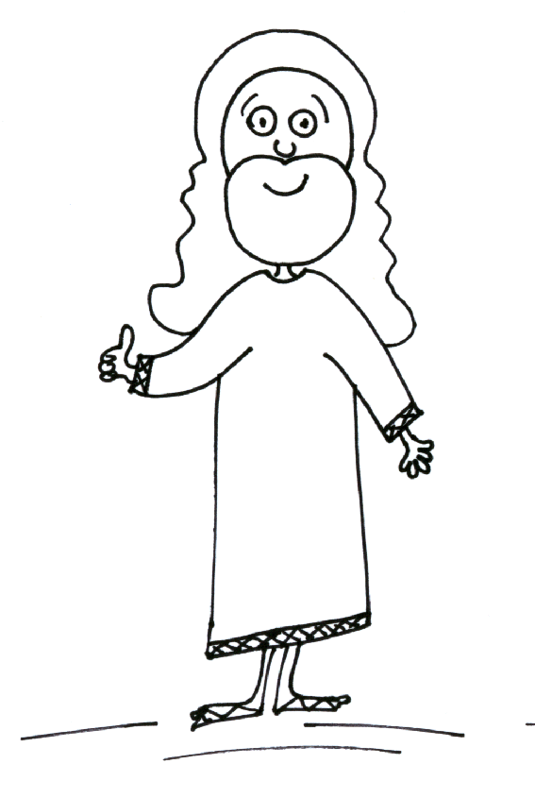

Activity sent by Carolina von Scharten, London
Sir William Crookes Spiritist Society linked to
BUSS - The British Union of Spiritist Societies.

