Colour the boat in yellow and the sea in blue.

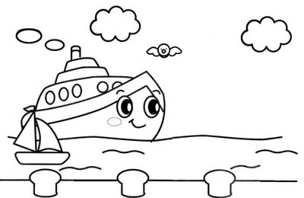

Image from the site: Art no Lapis

Activity received from Carolina von Scharten, London
Sir William Crookes Spiritist Society linked to
BUSS - The British Union of Spiritist Societies.

