CONNECT THE DOTS AND SEE THE RESULT!

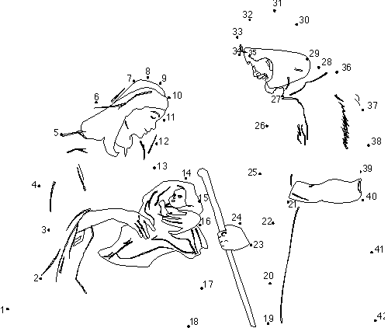

Source: Calvary Kids Pages

Activity received from Carolina von Scharten, London
Sir William Crookes Spiritist Society linked to
BUSS - The British Union of Spiritist Societies.

