Activity: Jesus is leading the boat!

Then he got into the boat and his disciples followed him. Without warning, a furious storm came up on the lake, so that the waves swept over the boat. But Jesus was sleeping. The disciples went and woke him, saying, "Lord, save us! We're going to drown!"
He replied, "You of little faith, why are you so afraid?" Then he got up and rebuked the winds and the waves, and it was completely calm.

The men were amazed and asked, "What kind of man is this? Even the winds and the waves obey him!" (Matthew, 8:23-27)

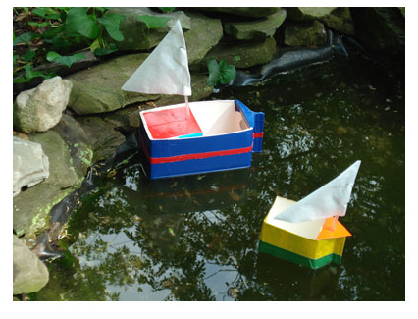

Instructions
1. Lay carton on side, so that the carton has a "pointed" bow. Carefully cut the top side away. It is easier if you poke a hole into the centre and then make a big X, then cut along the sides to remove the entire side.
2. Each boat can be customized by adding extra little boxes to the inside of the "boat" or adding a paper tube for a smokestack, etc.
3. We taped the sides and front bow section with coloured duct tape but you can also use permanent markers to colour plain duct tape. Decorate with stripes, squares, etc. Since the boats float on top of the water, you could even colour masking tape. Permanent colour markers would work also.
4. For our big boat (1/2 gal size), we took the bottom section of another 1/2 gal carton and made it into a cabin of sorts.
5.To make a sail, fold a napkin in half, making a triangle, and then make tiny slits along the edge (not too close to edge or it will tear). Insert the straw into the slits, weaving from front to back. Tape the top of the napkin to straw to hold in place.
6. Make a small hole, either in the bow of the boat, or if you made a cabin, to slide the straw "pole" into to keep in place. You could also tape the "pole" to the side or back of your boat.

Need:
•Milk carton
•Straw
•Napkin
•Scissors
•Tape
•Coloured Duct Tape (optional)

Source: Ziggity Zoom

Activity sent us by Carolina von Scharten, London Sir William Crookes Spiritist Society linked to
BUSS - The British Union of Spiritist Societies.

