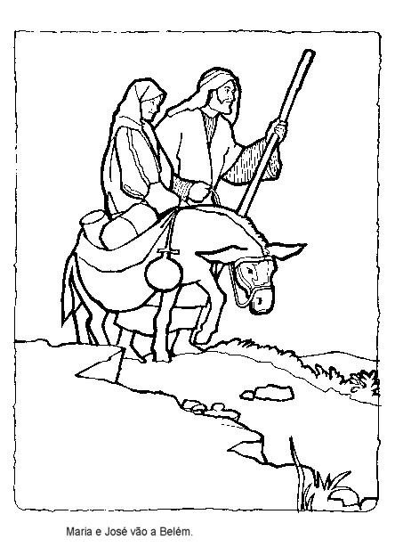
Mary and Joseph go to Bethlehem

Source: http://www.freewebs.com/vrstefanello/jesusparacolorir.htm

