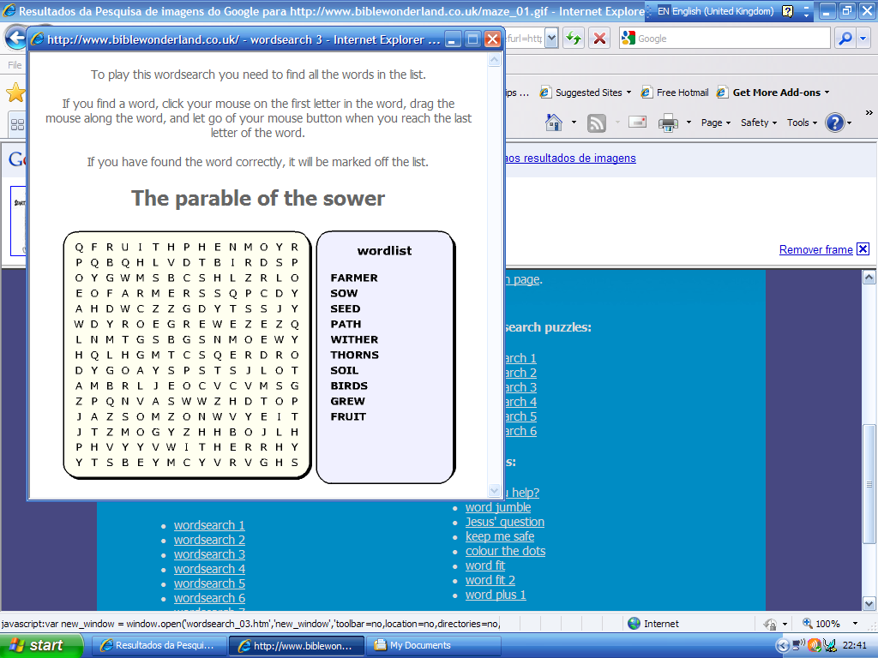

Source: Bible wonderland

Activity sent us by Carolina von Scharten, London
Sir William Crookes Spiritist Society linked to
BUSS - The British Union of Spiritist Societies.

