Once upon a time... Hippolyte Léon Denizard Rivail

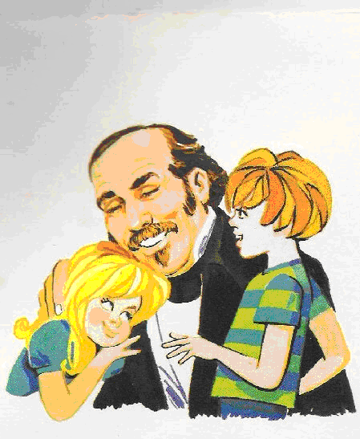

A long time ago... a boy was born, on 3rd October 1804, in a country called France, far away from here, in Lyon. He was called Hippolyte Léon Denizard Rivail, a rather difficult name since he was French.

The boy grew up to be well educated, intelligent and good.

When he was ten years old, his parents sent him to another country – Switzerland – to the city of Yverdun, to continue his studies. Yverdun was a meeting point for children from all over the world, since at that time its school was the best. It was a school that emphasized fraternal values and took care to ensure the children and youth became responsible and useful in society.

Rivail became a great teacher. When he moved to Paris, the French capital, he began teaching many youngsters at his house free of charge as they couldn’t afford to go to school.

As a result of Rivail’s extensive studies, he learnt to speak many other languages other than his mother tongue French.

Around 1831, something very fortunate took place. He met Amélie Gabrielle Boudet, whom he married a year later. She was also a teacher.

Rivail and his wife worked very hard. He wrote school books, among other things, thus becoming well-known and respected.

When he was about 50 years old, he became aware, through a friend, that some strange things were occurring in the city. His friend told him that in a certain meeting he attended objects moved around and a table started speaking.

Being accustomed to studying and researching phenomena, Rivail found that very illogical. After his friend kept on insisting he finally decided to attend one of the meetings.

There he saw for the first time the tables moving on their own. Moreover, various objects, such as vases, flowers and hats levitated through the air, without any support.

Soon the teacher realised that there must be another cause if the people there were didn't have anything to do with those events. He then began his research. He started to attend the weekly meetings, eager to find out what was behind all that.

First of all, there was a special method to communicate with the table. When it tapped the floor once with one of its legs, that meant ‘no’; tapping the floor twice meant ‘yes’. Later he established a convention for communicating the letters of the alphabet – the first letter being one tap, the second one two taps and so on. Afterwards, to make this process a bit faster, one person dictated the letters of the alphabet and the table tapped the floor when the desired letter was spoken. In this way, a conversation could be established, obtaining answers to questions.

Communicating in this way, Rivail asked who made the table move and obtained the following answer:

- It is us spirits.

Continuing with the dialogue through taps, the spirits revealed that they were nothing more than the souls of men who had already left their bodies. They were not ghosts. They simply did not have a physical body. They had died, as we say in our everyday speech.

In the same way, Rivail found out that when people died, they continued to live on, but in another body. Spirits also told him that he had lived other lives himself and was once known as Allan Kardec.

Continuing to ask questions and recording the answers, going back with more questions, all the while taking down what was said, comparing, and studying, Rivail compiled all the teachings into a book: ‘The Spirit’s Book’, which he published under the now-familiar pen name of “Allan Kardec” for two reasons: he was already well-known for the books that he had written as a teacher, and secondly, it was not really his work, but the teaching of the spirits.

In conclusion, Spiritism is a doctrine revealed by spirits and compiled in book form by Allan Kardec.

Allan Kardec disincarnated on 31st March 1869.

Rivail’s wife outlived him and up to her disincarnation she continued to work to propagate the Spiritist doctrine.

Bibliography: Apostila de Evangelização Infantil (Handout for Evangelisation of Children)
Federação Espírita do Paraná (Spiritist Federation of the state of Paraná, Brazil)
1º Ciclo de Infância - Unidade V = Espiritismo (1st stage of childhood – Unit 5 – Spiritism

Translation: Fabrício Marques - Inglaterra

