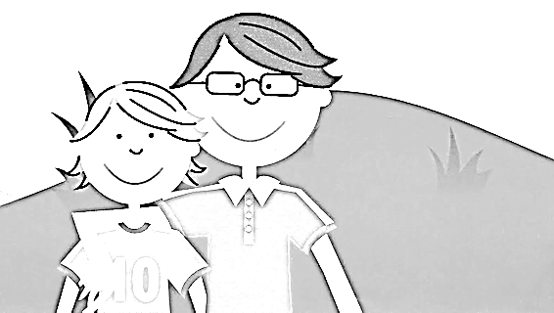

LAW OF CAUSE AND EFFECT
God governs the Universe based on the Law of Cause and Effect. Everything that happens has a cause and a consequence. Each person is responsible for his/her actions and reaps the consequences of what he/she does. The consequences of the actions may be positive if the actions are positive; or they can be negative, if the actions are negative. Good feelings, good thoughts and good actions bring us positive consequences.
LOVE
FRIENDSHIP
PEACE
CARING
HUMILITY
FAITH
CHARITY
HONESTY

