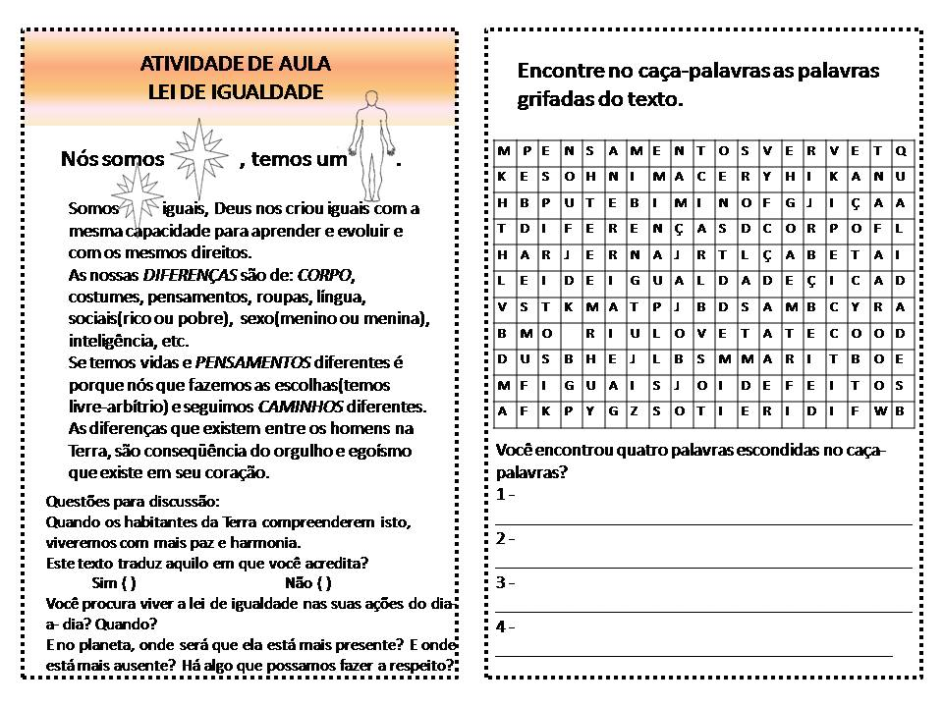

Fonte: evangelizacao-infantil.blogspot.com

Atividade recebida de Carolina von Scharten, London
Sir William Crookes Spiritist Society linked to
BUSS - The British Union of Spiritist Societies.

