A school called Earth

Our school is called earth and is a small class, among many others that exist in the universe. The main lesson is love for all. Above all, we should have love and gratitude for God, the Owner of the School and for the governor, our Master Jesus. Based on what we learned, how do we want to spend the year? How are our grades on subjects like Forgiveness, Faith, Patience, Love and Charity? Instead of waiting for the Owner to give us a present, because He already does that every day, what can we offer Him? Let's think about it from now on?

Let’s pursue to study the core subjects and put these into practice?

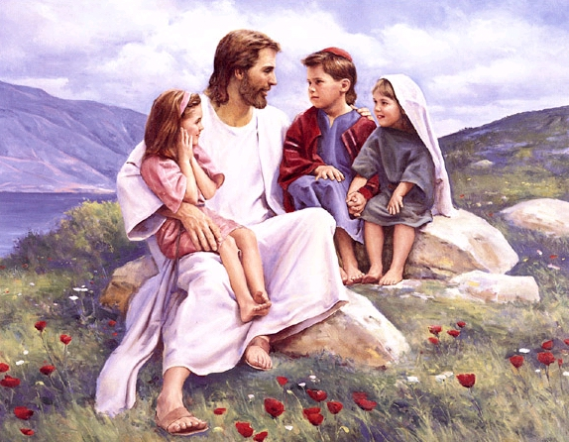

What are the rules that the Director has left us to follow:

- Love God above all things.
- To love all our brothers, being them plants, animals or people (of whatever race, religion, place, good or bad); we should love everything that God created.
- Do unto others as you want do to you.

What is love?

Respect, seeking to understand the mistakes of others, not to offend, not to practice any form of violence whether by words, deeds or thoughts. To do good whenever possible, at all times. Have patience, know how to wait, do not answer evil, do not criticize, do not judge, wishing well, forgive the mistakes of others as we want to be forgiven.

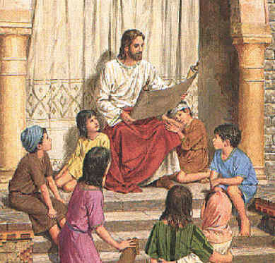
Our planet is of Tests and Atonements, and to transform it to a world of Regeneration we must all contribute. There are several things / situations that need to change for the better of the planet.
What things will cease to exist in this world of Tests and Atonements? It is suggested that the spiritist teacher makes a parallel to observe the differences/changes between the two worlds.
- Cigarettes, liquor, beer, drugs;
- Lies, dishonesty, unfairness, lack of ethics;
- Being too lazy to study and work;
- Disrespect for nature; garbage, filth, neglect recycling, graffiti, swearing;
- Waste of water, food and clothing;
- Special day for celebrations marked by consumerism;
- Luxury, vanity, fashion, piercings, tattoos, jewellery;
- Rave parties, bars, carnival, rock & roll;
- Slaughterhouses, poultry, cages, mistreated and abandoned animals;
- disrespect at schools, mess, noise, fights, cheating at exams, skipping classes;
- Violence, war, prejudice, corruption, assaults, kidnappings;
- Pornography, infidelity, divorce, abortion;
- Neglected children, poverty, homeless, slums, hunger;
- Anger, envy, gossip, deceit, offenses
And how will a World of Regeneration be like?
- Predominance of honesty, sincerity and trust;
- Greater responsibility to study and work;
- Greater awareness and appreciation of nature;
- respect to streets, squares, rivers, lakes, seas;
- Separation and processing of recyclable material;
- Animals respected, well-maintained, free;
- Simplicity, people more focused on matters related to the Spirit;
- a higher number of films and cultural programs, with good news;
- Relationships based on love and mutual respect, more harmony in the home;
- Many flowers, gardens, fruit trees, lawns, clean energy sources;
- Greater respect for children and the elderly;
- Predominance of well, the beginning of happiness.

