Shall we celebrate nature’s beauty? Fill in the top of the tree with dry leafs!

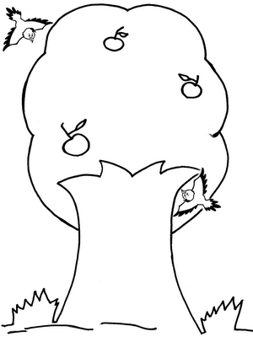

Source: giselle-curiosidades
Activity received from Carolina von Scharten, London - Sir William Crookes Spiritist Society linked to
BUSS - The British Union of Spiritist Societies.

