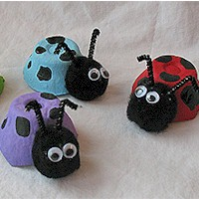
Egg Carton Lady Bugs

Recycle your old egg cartons into these adorable little ladybugs! So easy to make and such a cute result, what child could resist?

Supplies
Empty egg carton cup
Skinny black chenille, 2" piece
2 Small wiggle eyes
1 Medium black pom pom
Colorful acrylic paint
Black acrylic paint
Paintbrush
White craft glue
Hot glue gun
Scissors

Note: Use white craft glue for all instructions except where hot glue is indicated.

Instructions
- Use scissors to separate egg carton cups, trim the edges.
- Paint egg cartons in desired colors and let dry.
- Glue wiggle eyes on to black pom pom and let dry.
- Glue black pom pom on to side of egg cup with white craft glue and let dry completely, making sure eyes are facing out and are where you want them.
- Cut the 2" piece of skinny black chenille in half. Bend the end of each one to form the antannae. Use hot glue to attach antannaes to pom pom head.
- Use the handle end of a paintbrush to add black paint dots to the ladybug's back. Dip handle into paint and pick up a generous amount, then use a drawing motion to add the dot to the ladybug's back.
- Let dry completely.

Source: Amanda Formaro
Activity sent us by Carolina von Scharten, London
Sir William Crookes Spiritist Society linked to
BUSS - The British Union of Spiritist Societies.

