Egg Carton Cat Printable

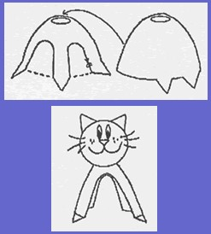

There are so many possibilities for using egg cartons. Here's another one that will provide hours of fun.

Supplies

Egg Carton
Scissors
Marker
Glue
Miscellaneous trim

Instructions

- Cut 2 individual egg cups apart. One will be the body and tabs can be cut at the four corners for the cat's feet. On that same cup, cut out the sides to make legs. The other cup will be the head section and two tabs can be cut out of two corners to make the ears.
- Glue the head section on top of the body section.
- Decorate the face by gluing grass, twigs, etc for whiskers, and a pompom, paint or felt for a nose. Attach a bit of yarn for a tail.
- The ears and tail can easily be changed to make a dog.

Source: Alberta Egg Producers

Activity sent us by Carolina von Scharten, London
Sir William Crookes Spiritist Society linked to
BUSS - The British Union of Spiritist Societies.

