Egg cardboard flowers

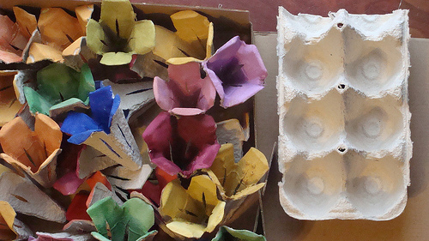

- Carefully cut individual cups off the egg carton.
- Next, cut points along the top of each cup so they look like tulips.
- Poke a hole in the bottom of an egg carton cup and push one end of a green pipe cleaner up through the hole and roll the end a little so it cannot slip back out of the hole.
- Colour them as you wish!
- If desired, you can cut leaves out of construction paper and glue them onto the chenille stems.

Source: Sherri Osborn, About.com Guide

Activity sent us by Carolina von Scharten, London
Sir William Crookes Spiritist Society linked to
BUSS - The British Union of Spiritist Societies.

