Scrap Cloth Pencil Holder 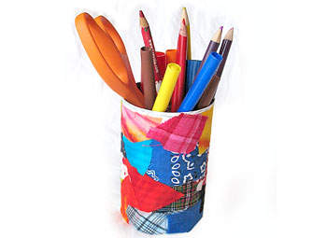
Age: 5 and up

Don’t throw away those bits and pieces of cloth that are left over from all your different projects. Save them and make new projects, such as this adorable and unique scrap coth pencil holder. A fun way to celebrate Earth Day!

What you'll need:
Empty aluminum can
White acrylic paint
Paintbrush
Fabric scraps
Scissors
White craft glue
Water

How to make it:
Mix together equal parts of white craft glue and water. Mixture should be paintable but not too thin.
Paint can with one coat of white craft paint. Let dry.
Start anywhere on the can, paint a small amount of glue mixture on to the surface. Apply a fabric scrap and paint more of the mixture over the top of the fabric and smooth it out. Repeat this process, overlapping the fabric scraps so that none of the can’s surface shows through.
Use scissors to trim any pieces of fabric that are sticking out above the can.
Let dry completely before using.

Tips:
Decoupage is great for many surfaces, including picture frames, wooden boxes, cardboard, glass and plastic.
Use zipper gallon storage bags to keep fabric scraps together. Squeeze out the air to store them as flat as possible.
If you like, add a lip of fabric or felt around the top of the can
Source: crafts.kaboose.com

Activity sent us by Carolina von Scharten, London
Sir William Crookes Spiritist Society linked to
BUSS - The British Union of Spiritist Societies.

