Individual Activity – THE COMFORTER
Cross-words

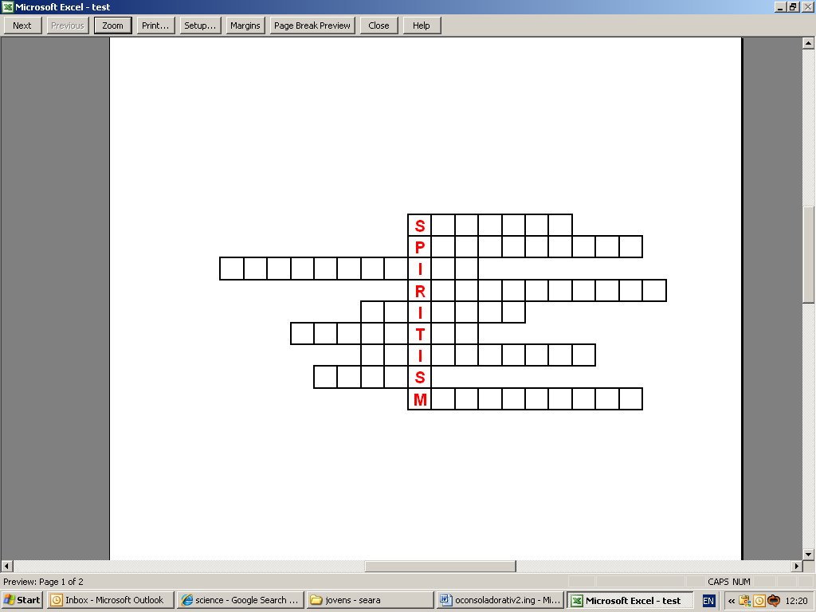

1. The intelligent beings of the creation. They populate the Universe.
2. Feature achieved by all the spirits after several incarnations.
3. Characteristic of the soul which survives the physical body.
4. Same as rebirth.
5. Aspect of Spiritism which studies mediumship phenomena and the relationship that can be established with the Spirits.
6. How does the person who believes in the manifestation of Spirits and endeavours to live the principles of Spiritism?
7. Aspect of Spiritism that reveals who we are, where we came from and where we go.
8. The most perfect type that God has offered to man as his guide and model.
9. Faculty that all people have to feel the influence of Spirits, in a greater or lesser extent.

