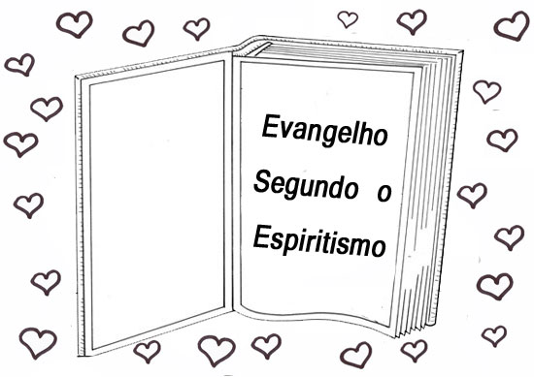
O
THE LORD’S PRAYER

THE GOSPEL
ACCORDING TO SPIRITISM

1 – Organise THE LORD’S PRAYER in the correct format.



       Forgive us our sins,
       hallowed be Your name!
       Forgive our offences,
       May Your will be done on Earth
       Give us this day our daily bread!
       Our Father in heaven,
       as we forgive those who offend us.
       So be it!
       as it is in heaven!
       Lead us not into temptation,
       as we forgive those who sin against us!
       May Your kingdom come!
( ) but deliver us from all evil.
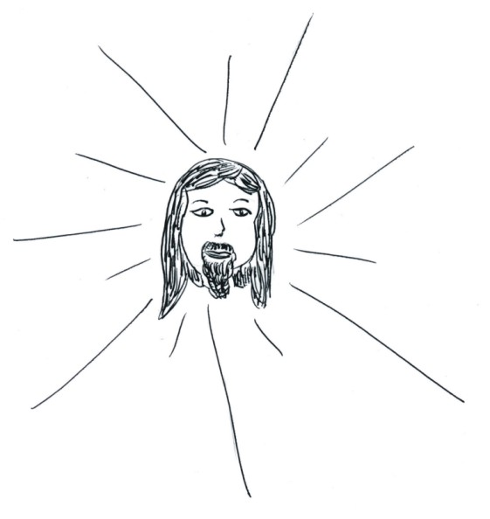
2) WHO TAUGHT US THE LORD’S PRAYER?

3) WRITE HERE BELOW A BEAUTIFUL PRAYER TO GOD, OUR FATHER:

PRAYER
PrAYER IS A CHAT WITH HAVE WITH GOD.
We can pray any time; anywhere, whenever we connect with God.
The prayer has three main objectives: to thank God, to ask and to praise God.
A prayer doesn’t need to be repetitious or complex to be effective. Only heartfelt and true The most important thing is that a prayer should express our inner feelings. God always listens to our prayers.
Vocabulary
Debts: wrong choices we made in the past which cause others or ourselves to suffer; mistakes
Kingdom: inner happiness felt when we follow God’s laws.
Temptation: something that drives us forward.

Name: ________________________________________________________ ___/___/___

